Eugene Debs – Canton, Ohio Anti-War Speech – June 18th, 1918 – Source – Eugene Debs Foundation - Eugene Debs, a leader of the Socialist Party who had made several unsuccessful bids for president, made the following speech below in protest of World War I. Below is a text excerpt from the speech:
Comrades, friends and fellow-workers, for this very cordial greeting, this very hearty reception, I thank you all with the fullest appreciation of your interest in and your devotion to the cause for which I am to speak to you this afternoon.
To speak for labor; to plead the cause of the men and women and children who toil; to serve the working class, has always been to me a high privilege; a duty of love.
I have just returned from a visit over yonder, where three of our most loyal comrades are paying the penalty for their devotion to the cause of the working class. They have come to realize, as many of us have, that it is extremely dangerous to exercise the constitutional right of free speech in a country fighting to make democracy safe in the world.
I realize that, in speaking to you this afternoon, there are certain limitations placed upon the right of free speech. I must be exceedingly careful, prudent, as to what I say, and even more careful and prudent as to how I say it. I may not be able to say all I think; but I am not going to say anything that I do not think. I would rather a thousand times be a free soul in jail than to be a sycophant and coward in the streets. They may put those boys in jail—and some of the rest of us in jail—but they cannot put the Socialist movement in jail. Those prison bars separate their bodies from ours, but their souls are here this afternoon. They are simply paying the penalty that all men have paid in all the ages of history for standing erect, and for seeking to pave the way to better conditions for mankind…
… Wars throughout history have been waged for conquest and plunder. In the Middle Ages when the feudal lords who inhabited the castles whose towers may still be seen along the Rhine concluded to enlarge their domains, to increase their power, their prestige and their wealth they declared war upon one another. But they themselves did not go to war any more than the modern feudal lords, the barons of Wall Street go to war. The feudal barons of the Middle Ages, the economic predecessors of the capitalists of our day, declared all wars. And their miserable serfs fought all the battles. The poor, ignorant serfs had been taught to revere their masters; to believe that when their masters declared war upon one another, it was their patriotic duty to fall upon one another and to cut one another’s throats for the profit and glory of the lords and barons who held them in contempt. And that is war in a nutshell. The master class has always declared the wars; the subject class has always fought the battles. The master class has had all to gain and nothing to lose, while the subject class has had nothing to gain and all to lose—especially their lives.
They have always taught and trained you to believe it to be your patriotic duty to go to war and to have yourselves slaughtered at their command. But in all the history of the world you, the people, have never had a voice in declaring war, and strange as it certainly appears, no war by any nation in any age has ever been declared by the people.
And here let me emphasize the fact—and it cannot be repeated too often—that the working class who fight all the battles, the working class who make the supreme sacrifices, the working class who freely shed their blood and furnish the corpses, have never yet had a voice in either declaring war or making peace. It is the ruling class that invariably does both. They alone declare war and they alone make peace.
Yours not to reason why; Yours but to do and die.
That is their motto and we object on the part of the awakening workers of this nation.
If war is right let it be declared by the people. You who have your lives to lose, you certainly above all others have the right to decide the momentous issue of war or peace.

“Get the Rope!”
In the early 20th century, German Americans were the nation’s largest immigrant group. Although they were regarded as a model of successful assimilation, they faced vicious—and sometimes violent—attacks on their loyalty when the United States went to war against Germany in 1917. The most notorious incident was the lynching of German-born Robert Prager in Colinsville, Illinois, in April 1918. Other incidents stopped just short of murder. In a statement made on October 22, 1918, John Deml, a farmer in Outagamie County, a heavily German and Scandinavian area of Wisconsin, described the nativist mob that had visited him two days earlier. Suspected of not showing strong enough support for the war effort, he was narrowly saved from lynching.
A Statement made by John Deml of Outagamie County, Wisconsin, at Madison, Wisconsin, Tuesday, October 22, 1918:
“About half-past twelve (continuing for more than an hour) Sunday morning October 20th, my wife awaked me, saying, that there were a large number of men on the front porch, pounding and rapping on the door, besides talking in a loud tone of voice. I was upstairs; then I came downstairs and went to the front door, where they were, and I asked them, who was there! Several answered at once, “The Council of Defense.” I then asked them, “What do you want?” and they replied, “We want you to sign up.” I replied, “I have done my share.” And they asked me when, and I replied, “I did my share in the spring.”(That is, I meant to say I had done my share in the third loan, when I subscribed for $450 in bonds.) To make it plain, on the 28th of September, at the opening of the fourth drive, I was notified by letter that my bond assessment would be $800. When Henry Baumann came to see me, I told him I could not possibly take $500 now but would take some, meaning a substantial amount, that is all I could afford; and he replied, “My orders are you must take $500 or nothing.”
After I had replied that I had done my share in the spring, they demanded that I open the door and let them in. I told them I didn’t have to open the door; then they undertook to force the door open, and went so far as to tear the screen door open; then they threatened to break down the door, and I said, “Come on then, boys.” Then they appeared to be planning, and while they were doing that, I took the time to put my shoes on. By that time they were at the kitchen door, and they made a demand that I let them in through that door; then I went to the kitchen door and opened it and found a crowd of men (much larger than I expected) around the door, and then reaching out two by two around towards the front of the house. I left the door and walked to the front porch to see if they had done any painting (as they had previously painted a neighbor’s mail-box); I walked to the road to see if they had painted my mail-box. And then I turned around to return to the house when they all at one time closed in on me like a vise; some grabbing my fingers or wrist, others my legs, and several of them were shouting, holding a paper before me, “Sign up.” I said, “I will not sign up at this time of night.” Then a man shouted, “Get the rope!” The first I knew was when the rope was about my neck and around my body under my arms. Someone then gave a sharp jerk at the rope and forced me to my knees and hands; at the same time some of them jumped on my back, and while bent over someone struck me in the face, making me bleed; then a man (whom I recognized) said, “Boys, you are going too far”; and then, as they got me away from them a little, I heard a man say, “You can’t scare him.” I answered, “I am not afraid of the entire city of Appleton.” Then a man (whom I knew) got me to one side, and he said, “Let’s go into the house and talk between ourselves.” Then two men (whom I knew) went with me into the house, and we sat or stood around the table, and they still demanded that I sign up. I said, “I will not sign up for any man after being abused like this.” Then a man (whom I knew) told me I would have to go with them, or, if I didn’t go with them, would have to come to town that Sunday morning at 10 o’clock to see Mr. Keller. I told them that I would be there; they left; as they left, I noticed, and so did my family and neighbors, that they rode away in seven automobiles. I did not go to see Mr. Keller. Signed, JOHN DEML.
Source: “Prussianizing Wisconsin,” Atlantic Monthly, Vol. 11, January 1919, No.1 pp. 101–102.

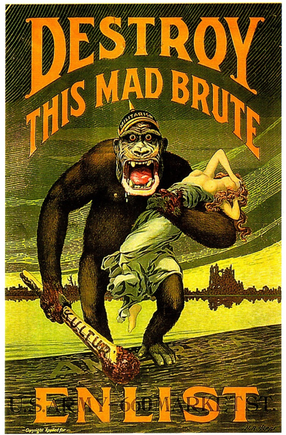
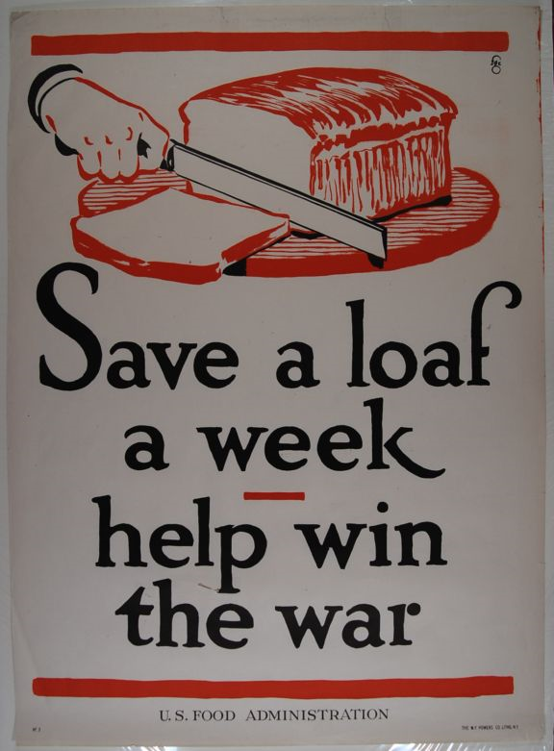
B
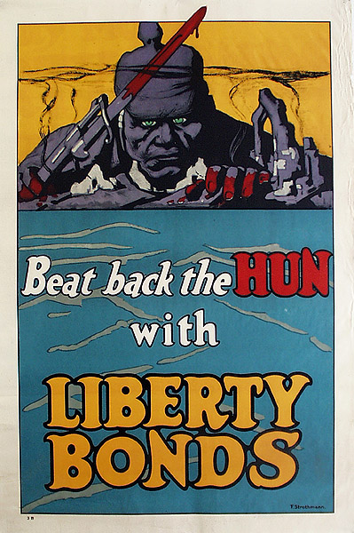
C
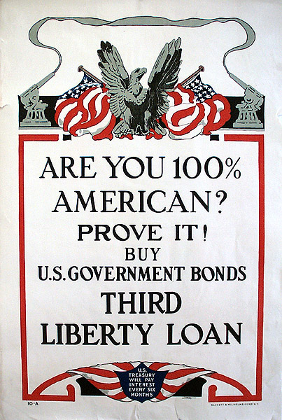
D
Response: Use the historical thinking skill of contextualization to make a concise response that connects the included documents together as well as to the broad set of implications and issues that came with United States entrance into World War I. Key sections of Chapter 30 of the textbook may be helpful to you.
To remind you, as defined by College Board Contextualization is the following:
Contextualization is historical thinking that involves the ability to connect historical developments to specific circumstances in time and place, and to broader regional, national or global processes.

- Propaganda posters are paired with “Get the Rope” and Eugene Debs’ Speech.

